Site Purpose:

The site will provide business information (navigation, contact, etc) and local area information (summary of coastal area, weather information, etc). Also, a way to build a fruit drink. Finally, an About Us page with historical information about the company and area.

Target Audience:

The target audience will be individuals who are in their 20s and 30s both male and females (although females will tend to be higher in business than males. 65% females vs 35% males). Specifically those that are more concerned for their health and looking for an organic alternative to the produce at grocery stores.

Site Map:

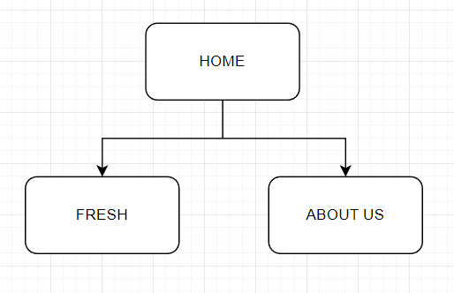

Color Scheme:

<https://coolors.co/6c3e1c-cc0000-7b8300-bab4a1-213129>

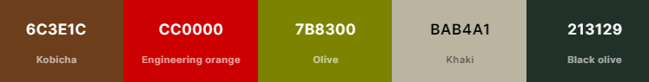

Primary: Olive 7b300

Secondary: kobicha 6c3e1c

Accent: Engineering Orange CC0000

Typography: black olive 213129

Others: khaki bab4a1

Typography:

font-family: 'Alkatra', cursive; --- --- -- page headers

font-family: 'Caveat', cursive; ---  -- page sub-headers

font-family: 'Delicious Handrawn', cursive; ---  -- page sub-headers

font-family: 'Lato', sans-serif; ---  -- paragraphs

font-family: 'Roboto', sans-serif; ---  -- paragraphs

Wireframe Sketches:

Large: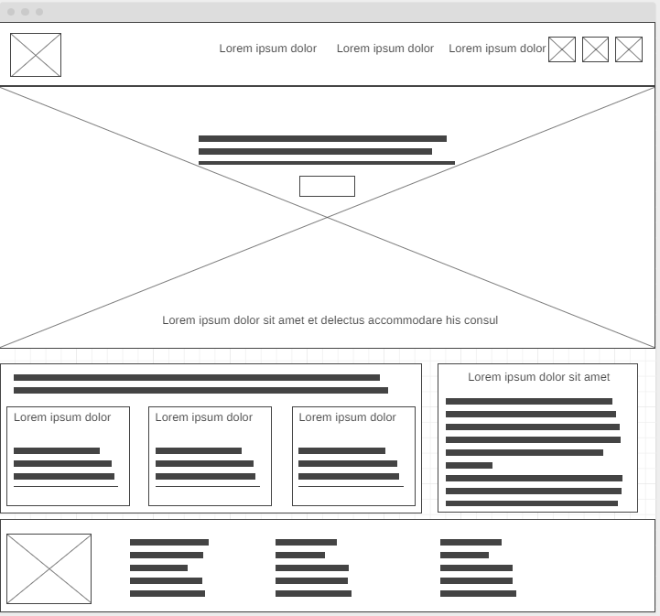

Medium: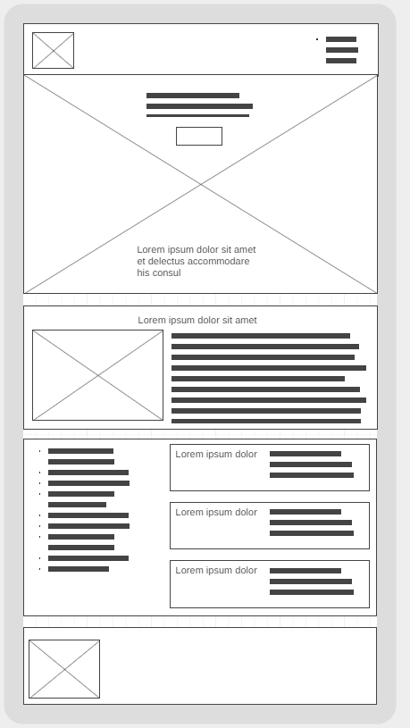 Small: